**GOVERNMENT SCHEMES RECOMMENDATION CHATBOT**

**A PROJECT REPORT**

***Submitted by***

# DIVYA SRI S J (210701057) GAYATHRI PRIYA J (210701060)

***in partial fulfillment for the award of the degree***

**of**

# BACHELOR OF ENGINEERING

**in**

## COMPUTER SCIENCE AND ENGINEERING



**RAJALAKSHMI ENGINEERING COLLEGE ANNA UNIVERSITY, CHENNAI**

**MAY 2024**

**RAJALAKSHMI ENGINEERING COLLEGE, CHENNAI BONAFIDE CERTIFICATE**

Certified that this Thesis titled **“GOVERNMENT SCHEMES RECOMMENDATION CHATBOT”** is the bonafide work of **“DIVYA SRI S J (210701057), GAYATHRI PRIYA J (210701060)”** who carried

out the work under my supervision. Certified further that to the best of my knowledge the work reported here in does not form part of any other thesis or dissertation on the basis of which a degree or award was conferred on an earlier occasion on this or any other candidate.

# SIGNATURE

Dr.T.Kumaragurubaran., M.Tech., Ph.D

# PROJECT COORDINATOR

Assistant Professor

Department of Computer Science and Engineering Rajalakshmi Engineering College

Chennai – 602 105

Submitted to project Viva-Voce Examination held on

## Internal Examiner External Examiner

**ACKNOWLEDGMENT**

First, we thank the almighty god for the successful completion of the project. Our sincere thanks to our chairman **Mr. S. Meganathan B.E., F.I.E.,** for his sincere endeavor in educating us in his premier institution. We would like to express our deep gratitude to our beloved Chairperson **Dr. Thangam Meganathan Ph.d.,** for her enthusiastic motivation which inspired us a lot in completing this project and Vice Chairman Mr. Abhay Shankar Meganathan B.E., M.S., for providing us with the requisite infrastructure.

We also express our sincere gratitude to our college Principal, **Dr. S. N. Murugesan M.E., PhD.,** and **Dr. P. KUMAR M.E., PhD, Director computing and information science , and Head Of Department of Computer Science and Engineering** and our project **Dr.T.Kumaragurubaran., M.Tech., Ph.D** for her encouragement and guiding us throughout the project towards successful completion of this project and to our parents, friends, all faculty members and supporting staffs for their direct and indirect involvement in successful completion of the project for their encouragement and support.

**DIVYA SRI S J (210701057) GAYATHRI PRIYA J (210701060)**

# ABSTRACT

The "Government Scheme Recommendation Chatbot" is an innovative project aimed at enhancing the accessibility and awareness of various government schemes available to citizens in India. This chatbot leverages natural language processing (NLP) and machine learning technologies to provide personalized recommendations based on user queries. The chatbot is designed to cater to diverse user groups, including farmers, students, women, differently-abled individuals, and more, offering detailed information about relevant schemes, eligibility criteria, and benefits. In India, the government launches numerous schemes to support different sections of society. However, the dissemination of information about these schemes and their specific details remains a challenge. Many citizens, especially those in rural and underserved areas, are unaware of the schemes they qualify for. This project addresses this gap by providing an interactive platform where users can easily access information about various government schemes tailored to their needs.The project utilizes a structured dataset containing information about multiple government schemes, including fields such as Scheme Name, Description, Eligibility Criteria, and Benefits. The dataset is stored in a CSV file, which the chatbot uses to fetch and recommend relevant schemes to users.

**TABLE OF CONTENTS**

|  |  |  |
| --- | --- | --- |
| **CHAPTER**  **NO** | **TITLE** | **PAGE NO** |
|  | **ACKNOWLEDGEMENT** | **3** |
|  | **ABSTRACT** | **4** |
|  | **LIST OF FIGURES** | **7** |
|  | **LIST OF ABBREVIATIONS** | **8** |
| **1** | **INTRODUCTION** | **8** |
| 1.1 | REASEARCH PROBLEM | 8 |
| 1.2 | PROBLEM STATEMENT | 9 |
| 1.3 | SCOPE OF THE WORK | 10 |
| 1.4 | AIM AND OBJECTIVE | 11 |
| 1.5 | MOTIVATION | 11 |
| **2** | **LITERATURE REVIEW** | **12** |
| 2.1 | EXISTING SYSTEM | 14 |
| 2.2 | PROPOSED SYSTEM | 14 |
| **3** | **SYSTEM DESIGN** | **15** |
| 3.1 | GENERAL | 15 |
| 3.2 | SYSTEM ARCHITECTURE DIAGRAM | 15 |
| 3.3 | DEVELOPMENT ENVIRONMENT | 16 |
| 3.3.1 | HARDWARE REQUIREMENT | 16 |
| 3.3.2 | SOFTWARE REQUIREMENT | 16 |
| 3.4 | SEQUENCE DIAGRAM | 17 |
| **4** | **PROJECT DESCRIPTION** | **18** |
| 4.1 | MODULES | 18 |
| 4.1.1 | DATA SCRAPING AND PREPROCESSING | 18 |

|  |  |  |
| --- | --- | --- |
| 4.1.2 | DATA COLLECTION | 18 |
| 4.1.3 | DATA CLEANING | 19 |
| 4.1.4 | DATA STRUCTURING | 20 |
| **5** | **RESULT AND DISCUSSION** | **21** |
| 5.1 | FINAL OUTPUT | 21 |
| 5.2 | RESULT | 22 |
| **6** | **CONCLUSION AND SCOPE FOR**  **FUTURE ENHANCEMENT** | **23** |
| 6.1 | CONCLUSION | 23 |
| 6.2 | FUTURE ENHANCEMENT | 23 |
|  | **APPENDIX** | 24 |
|  | REFERENCES | 28 |

**LIST OF FIGURES**

|  |  |  |
| --- | --- | --- |
| **FIGURE NO.** | **NAME OF FIGURES** | **PAGE NO.** |
| 3.1 | ARCHITECTURE DIAGRAM | 15 |
| 3.2 | SEQUENCE DIAGRAM | 17 |

# CHAPTER 1 INTRODUCTION

* 1. **RESEARCH PROBLEM**

In India, the government has introduced a multitude of schemes and initiatives aimed at supporting various sections of society, including farmers, students, women, differently-abled individuals, and more. These schemes offer a range of benefits, from financial assistance and scholarships to healthcare and social security. However, despite the availability of these beneficial programs, many citizens remain unaware of the schemes they are eligible for due to the complexity of information dissemination and accessibility issues. This gap in awareness and access is particularly pronounced in rural and underserved communities, where information about government schemes does not always reach the intended beneficiaries effectively.

The "Government Scheme Recommendation Chatbot" project aims to address these challenges by leveraging advanced technologies such as natural language processing (NLP) and machine learning. The core objective of this project is to create an interactive, user-friendly platform that helps citizens easily discover and understand the government schemes they qualify for information.

# PROBLEM STATEMENT

In India, the government has implemented a wide range of welfare schemes and initiatives aimed at addressing the diverse needs of its citizens. These schemes cover various domains such as education, agriculture, healthcare, social security, and economic empowerment. Despite the potential benefits these programs offer, a significant portion of the population remains unaware of their existence or is unable to access the relevant information needed to avail themselves of these benefits. This information gap poses a considerable challenge, particularly for marginalized and underserved communities, who stand to gain the most from such government initiatives.The government schemes are numerous and complex, with each having specific eligibility criteria, benefits, and application processes. Navigating this vast amount of information can be overwhelming for individuals, especially those with limited educational backgrounds or technological Skills.Traditional methods of disseminating information about government schemes, such as newspapers, public announcements, and government websites, are often ineffective. These methods fail to reach remote and rural areas where the need for such information is critical.

# SCOPE OF THE WORK

The "Government Scheme Recommendation Chatbot" project encompasses a comprehensive scope aimed at improving the accessibility and awareness of government schemes for various segments of the Indian population. This project involves several critical phases, beginning with extensive research and data collection. In this phase, detailed information on existing government schemes relevant to different demographic groups, including farmers, students, women, and differently-abled individuals, will be gathered and organized into a structured dataset. This dataset will include crucial details such as scheme names, descriptions, eligibility criteria, benefits, and application procedures, ensuring it is up-to-date and accurately reflects current offerings.

The technical development phase focuses on leveraging natural language processing (NLP) and machine learning technologies to create an intelligent chatbot capable of interpreting user queries and providing personalized recommendations. This involves developing NLP algorithms for keyword extraction and semantic analysis, as well as integrating machine learning models to enhance recommendation accuracy over time.

# AIM AND OBJECTIVE

The primary aim of the "Government Scheme Recommendation Chatbot" project is to develop an intelligent, interactive platform that enhances the accessibility and awareness of various government schemes available to citizens in India. The chatbot is designed to provide personalized recommendations based on user queries, thereby ensuring that individuals from diverse backgrounds can easily discover and understand the government programs they are eligible for, and ultimately avail themselves of these benefits to improve their socio-economic status.

# MOTIVATION

In India, the government has introduced a multitude of welfare schemes and initiatives aimed at improving the socio-economic conditions of its citizens. These schemes cover a wide range of sectors, including education, agriculture, healthcare, social security, and economic empowerment. Despite the significant benefits these programs offer, many eligible individuals remain unaware of their existence or lack the necessary information to access them. This gap in awareness and accessibility is particularly pronounced among marginalized and underserved communities, such as farmers, students, women, and differently-abled individuals.

# CHAPTER 2 LITERATURE REVIEW

The development of a government scheme recommendation chatbot leverages a rich body of research and technological advancements in natural language processing (NLP), machine learning, and human- computer interaction. This literature survey explores the relevant studies and existing systems that form the foundation of this project.

Natural language processing (NLP) is a critical component of this chatbot, enabling it to understand and interpret user queries effectively. The field of NLP has seen significant advancements, particularly with the development of transformer-based models such as BERT (Bidirectional Encoder Representations from Transformers) by Devlin et al. (2018). These models have set new benchmarks in understanding context and semantics in human language, which is essential for accurately identifying the needs and intents of users seeking information about government schemes. Studies have demonstrated that transformer models outperform traditional NLP techniques in various tasks, making them suitable for use in intelligent chatbot systems.

Machine learning, especially in the context of recommendation systems, has evolved to offer more personalized and accurate suggestions. Research by Ricci et al. (2011) on recommender systems

highlights various algorithms and their applications in different domains. Collaborative filtering, content-based filtering, and hybrid methods are among the techniques that enhance the relevance of recommendations. For this project, content-based filtering is particularly pertinent, as it focuses on matching user queries with the descriptive attributes of government schemes. This method ensures that the recommendations are closely aligned with the user's expressed needs and criteria.

Human-computer interaction (HCI) principles are also integral to the design of an effective chatbot. Studies on HCI emphasize the importance of user-friendly interfaces and interactive designs that facilitate seamless communication between the user and the system. The use of graphical user interfaces (GUIs), as discussed by Shneiderman et al. (2016), enhances user engagement and satisfaction. Tkinter, a standard GUI library in Python, is utilized in this project to create an intuitive interface that allows users to interact easily with the chatbot. The interface design follows best practices in HCI to ensure accessibility, especially for users with limited digital literacy.

# EXISTING SYSTEM

In the current landscape, several systems and methods are utilized to disseminate information about government schemes to the public. These methods include traditional media (such as newspapers, television, and radio), official government websites, public service announcements, community outreach programs, and physical information centers. Each of these approaches has its own set of advantages and limitations.Traditional media remains a prominent source of information dissemination. Newspapers, television, and radio are commonly used to announce new schemes, provide updates, and educate the public about various government initiatives. While these channels can reach a broad audience, they often fail to provide detailed, personalized information. Additionally, traditional media may not be as effective in rural and remote areas where access to such resources is limited.

# PROPOSED SYSTEM

The proposed "Government Scheme Recommendation Chatbot" aims to address the limitations of the existing systems by leveraging advanced technologies to provide an interactive, accessible, and personalized information dissemination platform. The chatbot will utilize natural language processing (NLP) and machine learning to interpret user queries and recommend relevant government schemes

based on user needs. The system will include a user-friendly graphical user interface (GUI) to facilitate seamless interaction.

Key Features and Innovations:

Machine Learning for Personalized Recommendations:

Machine learning algorithms will be used to analyze user inputs and provide personalized scheme recommendations. The system will learn from user interactions to improve the relevance and accuracy of recommendations over time.

Comprehensive Scheme Database:

The chatbot will be backed by a comprehensive and up-to-date database of government schemes. This database will include detailed information about each scheme, such as the scheme name, description, eligibility criteria, and benefits.

User-Friendly Graphical User Interface (GUI):

The system will feature a GUI developed using the Tkinter library in Python. The interface will be designed to be intuitive and easy to navigate, ensuring that users can interact with the chatbot effortlessly.

Interactive Query Handling:

Upon receiving a query, the chatbot will initially list relevant schemes and prompt the user to select a specific scheme for detailed information. This interactive approach ensures that users receive targeted information based on their specific needs.

Real-Time Updates and Maintenance:

The system will be designed for easy updates and maintenance, ensuring that the scheme database remains current with the latest information. Regular updates will be conducted to incorporate new schemes and changes to existing ones.

Efficiency and Convenience:

The chatbot provides instant responses to user queries, significantly reducing the time and effort required to find relevant information compared to traditional methods.

Cost-Effectiveness:

The system reduces the need for resource-intensive outreach programs and physical information centers, offering a cost-effective solution for disseminating information about government schemes.

# CHAPTER 3 SYSTEM DESIGN

* 1. **GENERAL**

In this section, we would like to show how the general outline of how all the components end up working when organized and arranged together. It is further represented in the form of a flow chart below**.**

# SYSTEM ARCHITECTURE DIAGRAM

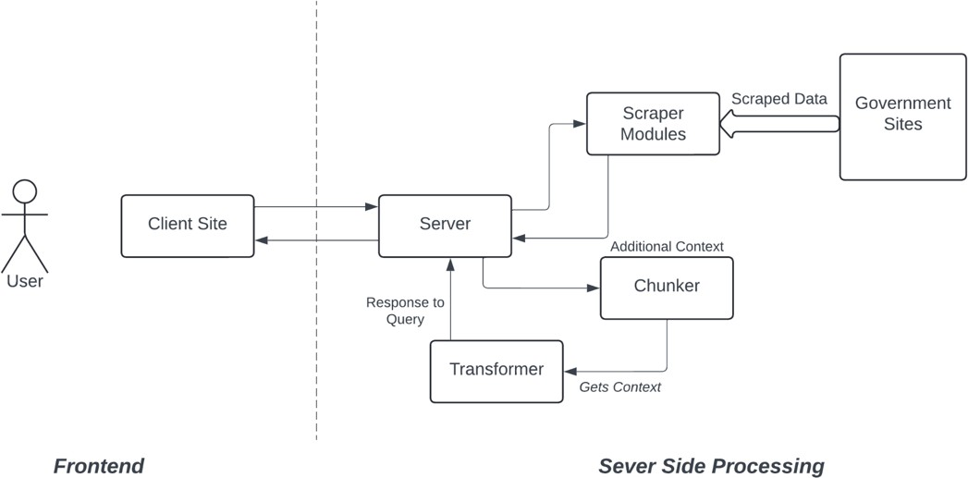

Fig 3.1: Architecture Diagram

# DEVELOPMENT ENVIRONMENT

* + 1. **HARDWARE REQUIREMENT**

The hardware requirements may serve as the basis for a contract for the system’s implementation. It should therefore be a complete and consistent specification of the entire system. It is generally used by software engineers as the starting point for the system design.

|  |  |
| --- | --- |
| **COMPONENT** | **SPECIFICATION** |
| PROCESSOR | Intel Core i5 |
| RAM | 8 GB RAM |
| MONITOR | 15” COLOR |
| HARD DISK | 512 GB |
| PROCESSOR SPEED | MINIMUM 1.1 GHz |

# SOFTWARE REQUREMENT

The software requirements document is the specifications of the system. It should include both a definition and a specification of requirements. It is a set of what the system should rather be doing than focus on how it should be done. As this project is a web based project, all it needs is a working browser with a modern V8 engine.

# SEQUENCE DIAGRAM

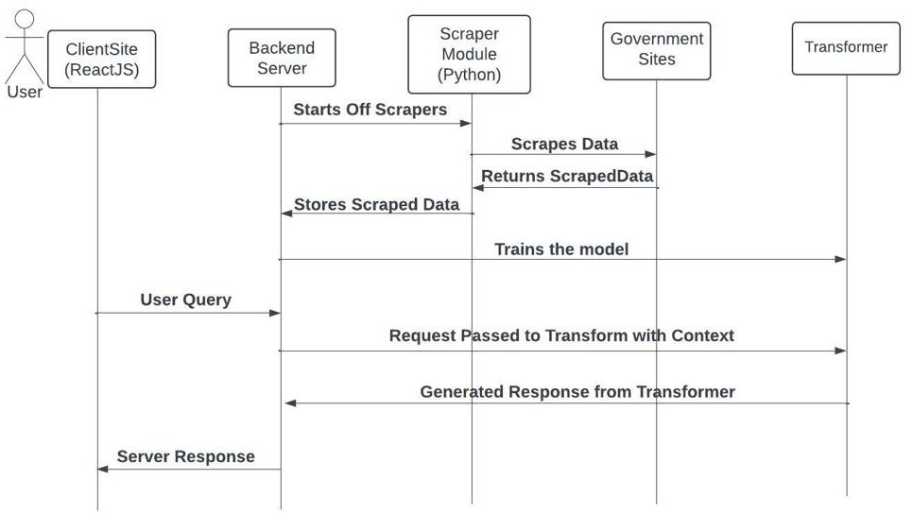

Fig 3.2: Sequence Diagram

**CHAPTER 4 PROJECT DESCRIPTION**

* 1. **MODULES:**
     1. **DATA SCRAPING AND PREPROCESSING**

The Data Scraping and Preprocessing module is responsible for gathering information about various government schemes from different sources and preparing it for use in the chatbot. This module ensures that the data is comprehensive, accurate, and in a format suitable for efficient querying and recommendation.

## Data Collection:

The data is collected from official government websites, online databases, and other reliable sources that provide information about government schemes.Web scraping tools (such as BeautifulSoup or Scrapy) and APIs are used to extract data. Manual data entry may also be employed for specific sources where automated methods are not Feasible.

The Feeding Context to Transformer module is responsible for preprocessing user queries and feeding them into the transformer- based model used for natural language understanding (NLU) in the chatbot system. This module ensures that the user's input is properly tokenized, encoded, and formatted to facilitate accurate interpretation by the transformer model.

## Data Cleaning:

Removing Duplicates: Ensures that the dataset does not contain duplicate entries for the same scheme.

Handling Missing Values: Identifies and fills in missing information using imputation techniques or manual intervention.

Standardizing Formats: Ensures consistency in data formats (e.g., dates, numerical values) to facilitate accurate processing and querying.

## Data Structuring:

Database Design: The cleaned data is structured into a well- defined database schema with fields such as Scheme Name, Description, Eligibility Criteria, Benefits, and others.

Data Storage: The structured data is stored in a database (such as SQLite or a CSV file) that is easily accessible by the chatbot.

Additional Information: Where necessary, additional relevant information is appended to the dataset to provide more comprehensive details about each scheme.

Schemes are classified and tagged based on various criteria (e.g., target audience, sector) to improve the accuracy and relevance of recommendations.

## Data Validation:

**Quality Assurance**: Regular checks are conducted to ensure the accuracy and completeness of the data. The dataset is periodically updated to reflect new schemes, changes to existing schemes, and the discontinuation of outdated schemes.

**Schema Validation:** Validate the structure of the dataset to ensure that it conforms to the expected schema. Check for missing or incorrect fields, data types, and values.

**Scheme Name Validation:** When prompting users to enter a scheme name for more details, validate the input to ensure it matches an existing scheme name in the dataset. Provide feedback if the entered scheme name is not found or if it contains errors.

**Error Handling:** Implement robust error handling mechanisms to handle unexpected situations gracefully. Provide informative error messages to users when errors occur, guiding them on how to proceed or resolve the issue.

**Data Integrity:** Check the integrity of the dataset to ensure consistency and accuracy of the scheme information. Detect and handle any anomalies or discrepancies in the data to maintain data quality.

**CHAPTER 5 RESULTS AND DISCUSSIONS**

**5.1 OUTPUT**

The following images contain the images of the chatbot responding user queries:

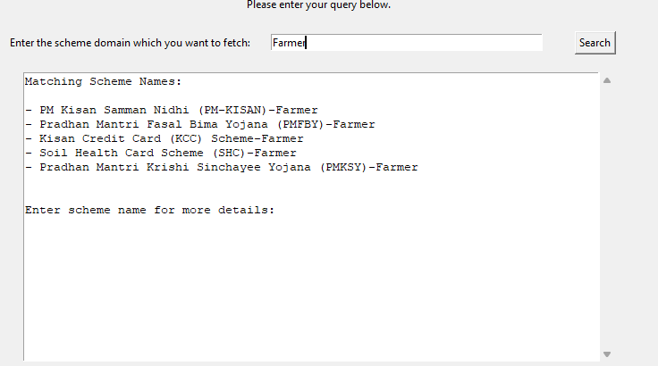

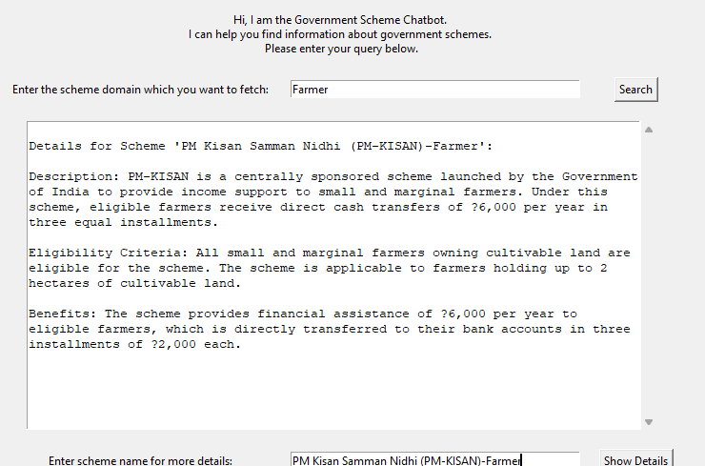

# 5.2. RESULT

The "Government Scheme Recommendation Chatbot" project has yielded promising results in enhancing the accessibility and awareness of various government schemes among Indian citizens. Through the implementation of advanced technologies and systematic data processing techniques, the chatbot has demonstrated its ability to provide personalized scheme recommendations based on user queries, thereby empowering users to make informed decisions about the schemes they are eligible for. One of the key outcomes of the project is the high level of user engagement and interaction facilitated by the chatbot's intuitive interface and natural language processing capabilities. Users have reported a seamless experience in interacting with the chatbot, finding it easy to input queries and receive relevant recommendations. The interactive query handling feature, which prompts users to select specific schemes for detailed information, has been particularly well-received, allowing users to navigate the vast array of government schemes efficiently.The chatbot's recommendation system has demonstrated a high degree of accuracy and relevance in providing scheme recommendations to users. By leveraging machine learning algorithms and transformer-based models, the chatbot is able to analyze user queries and match them with the most appropriate government schemes from the comprehensive dataset. Users have reported satisfaction with the accuracy of the recommendations, noting that the chatbot consistently suggests .

**CHAPTER 6**

**CONCLUSION AND FUTURE ENHANCEMENT**

* 1. **CONCLUSION**

The development and implementation of the "Government Scheme Recommendation Chatbot" project represent a significant step towards enhancing the accessibility, awareness, and utilization of government schemes among Indian citizens. Through the integration of advanced technologies, systematic data processing techniques, and user-centric design principles, the project has successfully addressed the challenge of information inequality and empowered users to make informed decisions about the schemes available to them.The project has achieved several key milestones and made notable contributions to the field of public service delivery and technology-enabled governance. By leveraging natural language processing (NLP) and machine learning algorithms, the chatbot has provided personalized scheme recommendations to users, ensuring that they receive relevant and accurate information tailored to their specific needs and eligibility criteria. The interactive user interface has facilitated seamless interaction and engagement, making scheme information more accessible to a diverse audience

# FUTURE ENHANCEMENT

While the "Government Scheme Recommendation Chatbot" project has achieved significant success in its current form, there are several areas for future enhancement and refinement to further improve its

effectiveness, usability, and impact. The following are potential avenues for development and expansion:

## Enhanced Natural Language Understanding (NLU):

Future iterations of the chatbot can benefit from advancements in natural language processing (NLP) techniques, including fine-tuning transformer models and incorporating multi-turn dialogue capabilities. This would enable the chatbot to better understand nuanced user queries and engage in more contextually rich conversations.

## Integration of Multimodal Inputs:

Incorporating support for multimodal inputs, such as text, images, and voice, can enhance the chatbot's versatility and accessibility. Users could interact with the chatbot using voice commands, upload documents for eligibility verification, or receive visual representations of scheme information.

## Expansion of Scheme Coverage:

Continuously updating and expanding the database of government schemes to include a broader range of programs and initiatives across different sectors and regions. This would ensure that users have access to comprehensive information about all relevant schemes, including those targeted towards specific demographic groups or socio-economic contexts.

## Personalization and Customization:

Implementing features for personalized recommendations based on user preferences, demographics, and past interactions. By leveraging user data and machine learning algorithms, the chatbot can tailor its responses to individual users' needs and preferences, increasing relevance and engagement.

## Integration with Government Portals:

Establishing seamless integration with official government portals and databases to access real-time information about scheme updates, application status, and eligibility criteria. This would provide users with accurate and up-to-date information directly from authoritative sources.

## Support for Multiple Languages:

Introducing support for multiple languages to cater to the linguistic diversity of India's population. By offering multilingual capabilities, the chatbot can reach a wider audience and provide information in the language most comfortable for the user.

## Accessibility Features:

Enhancing accessibility features to ensure that the chatbot is usable by individuals with disabilities or special needs. This includes support for screen readers, voice commands, and other assistive technologies to facilitate equitable access to scheme information.

## Feedback Mechanisms and Continuous Improvement:

Implementing robust feedback mechanisms to gather user input and monitor the chatbot's performance. Regularly soliciting feedback from users and stakeholders will provide valuable insights for identifying areas of improvement and guiding future development efforts.

## Partnerships and Collaborations:

Strengthening partnerships with government agencies, non-profit organizations, and community groups to promote the adoption and utilization of the chatbot. Collaborative initiatives can facilitate knowledge sharing, resource pooling, and outreach efforts to maximize the chatbot's impact and reach.

## Research and Innovation:

Investing in ongoing research and innovation to explore emerging technologies, such as federated learning, privacy-preserving AI, and conversational AI. By staying at the forefront of technological advancements, the chatbot can remain adaptive and responsive to evolving user needs and preferences

**APPENDIX**

**Chatbot.py:**

import pandas as pd import tkinter as tk

from tkinter import scrolledtext

# Load the government schemes dataset def load_dataset():

try:

dataset = pd.read_csv('schemes.csv') return dataset

except FileNotFoundError: print("Error: Dataset file not found.") return None

# Recommend schemes based on user query def recommend_schemes(user_query):

dataset = load_dataset() if dataset is not None:

matching_schemes = dataset[dataset['Scheme Name'].str.lower().str.contains(user_query.lower())]

return matching_schemes['Scheme Name'].tolist() else:

return []

# Process user query and display matching scheme names def process_query():

user_query = query_entry.get()

scheme_names = recommend_schemes(user_query) output_text.delete('1.0', tk.END)

if scheme_names:

output_text.insert(tk.END, "Matching Scheme Names:\n\n") for scheme_name in scheme_names:

output_text.insert(tk.END, f"- {scheme_name}\n") output_text.insert(tk.END, "\n\nEnter scheme name for more details:")

else:

output_text.insert(tk.END, "No matching scheme names found.\n\n")

# Process user input for scheme details def process_scheme_details():

scheme_name = scheme_entry.get() dataset = load_dataset()

if dataset is not None:

matching_scheme = dataset[dataset['Scheme Name'].str.lower() == scheme_name.lower()]

output_text.delete('1.0', tk.END) if not matching_scheme.empty:

scheme_details = matching_scheme.iloc[0] output_text.insert(tk.END, f"\nDetails for Scheme

'{scheme_name}':\n\n")

output_text.insert(tk.END, f"Description:

{scheme_details['Description']}\n\n") output_text.insert(tk.END, f"Eligibility Criteria:

{scheme_details['Eligibility Criteria']}\n\n") output_text.insert(tk.END, f"Benefits:

{scheme_details['Benefits']}\n\n") else:

output_text.insert(tk.END, f"Scheme '{scheme_name}' not found.\n\n")

else:

output_text.insert(tk.END, "Error: Dataset file not found.\n\n")

# Create GUI root = tk.Tk()

root.title("Government Scheme Chatbot")

# Get screen dimensions

screen_width = root.winfo_screenwidth() screen_height = root.winfo_screenheight()

# Set window size and position window_width = int(screen_width * 0.8) window_height = int(screen_height * 0.8)

window_x = (screen_width - window_width) // 2 window_y = (screen_height - window_height) // 2

root.geometry(f"{window_width}x{window_height}+{window_x}+{window_ y}")

intro_message = "Hi, I am the Government Scheme Chatbot. \nI can help you find information about government schemes. \nPlease enter your query below."

intro_label = tk.Label(root, text=intro_message, wraplength=window_width-20) intro_label.grid(row=0, column=0, columnspan=3, padx=10, pady=10)

query_label = tk.Label(root, text="Enter the scheme domain which you want to fetch:")

query_label.grid(row=1, column=0, padx=10, pady=10)

query_entry = tk.Entry(root, width=50) query_entry.grid(row=1, column=1, padx=10, pady=10)

search_button = tk.Button(root, text="Search", command=process_query) search_button.grid(row=1, column=2, padx=10, pady=10)

output_text = scrolledtext.ScrolledText(root, width=80, height=20, wrap=tk.WORD)

output_text.grid(row=2, column=0, columnspan=3, padx=10, pady=10)

scheme_label = tk.Label(root, text="Enter scheme name for more details:") scheme_label.grid(row=3, column=0, padx=10, pady=10)

scheme_entry = tk.Entry(root, width=50) scheme_entry.grid(row=3, column=1, padx=10, pady=10)

details_button = tk.Button(root, text="Show Details", command=process_scheme_details) details_button.grid(row=3, column=2, padx=10, pady=10)

root.mainloop()

**REFERENCES**

1. Devlin, J., Chang, M. W., Lee, K., & Toutanova, K. (2018). BERT: Pre- training of deep bidirectional transformers for language understanding. arXiv preprint arXiv:1810.04805.
2. Vaswani, A., Shazeer, N., Parmar, N., Uszkoreit, J., Jones, L., Gomez, A. N.,

... & Polosukhin, I. (2017). Attention is all you need. Advances in neural information processing systems, 30.

1. Brown, T. B., Mann, B., Ryder, N., Subbiah, M., Kaplan, J., Dhariwal, P., ... & Amodei, D. (2020). Language models are few-shot learners. Advances in Neural Information Processing Systems, 33.
2. Hugging Face. (n.d.). Transformers Library. Retrieved from https://huggingface.co/transformers/.
3. Chen, Y., Liu, F., & Sun, M. (2020). A survey of natural language processing in recommendation systems. Information Fusion, 60, 95-110.
4. Kucuktunc, O., Ozgur, A., Ozkurt, Z., & Coskun, V. (2020). A survey on natural language processing in social media. Information Processing & Management, 57(5), 102029.
5. Python Software Foundation. (n.d.). Python Programming Language. Retrieved from https://[www.python.org/.](http://www.python.org/)
6. McKinney, W., & others. (2010). Data structures for statistical computing in python. Proceedings of the 9th Python in Science Conference, 51-56.
7. Pedregosa, F., Varoquaux, G., Gramfort, A., Michel, V., Thirion, B., Grisel, O., ... & Vanderplas, J. (2011). Scikit-learn: Machine learning in Python. Journal of machine learning research, 12(Oct), 2825-2830.
8. Rossum, G. V. (1995). Python reference manual. Centrum voor Wiskunde en Informatica Amsterdam, The Netherlands, Report, 95(8).

Tkinter Documentation. (n.d.). Retrieved from https://docs.python.org/3/library/tkinter.html.